**WORK INSTRUCTIONS FOR GEL FLARE STACK**

**Criteria:** Complete flaring of BF gas through flare stack.

# OVERALL RESPONSIBILITY: Shift in charge, Control room, Furnace in Charge.

**Identified Hazards:**

1. BF Gas poisoning
2. Fall of person causing injury
3. Contact with hot surface causing burns
4. Human Behavior -Nonuse of PPE
5. Human Behavior -Improper house keeping
6. Inadequate local illumination
7. Breaking of flare stack water seal without the knowledge that people were working on top.
8. Human Behavior -Not following work permit procedure.
9. Declaring shutdown without water sealing all the valve of the line
10. Flare stacks flame failure leading to gas presence in plant area.
11. LPG leakage
12. Slipping from monkey ladder while climbing

**Significant Aspect**:

1. Usage of LPG.
2. Release of BF gas without flaring
3. Flue gas generation
4. Use of electrical energy

**Introduction**:

Ignition Burner is used on Flare stack for burning the Excess BFG gas which is generated in blast furnace. Burner consists of Air, BFG & LPG line connection and Ignition electrode for generating Spark. Combustion takes place inside the burner by adjusting Air to Gas ratio and with spark.

Electrical circuit is given for giving spark for 10sec due to this spark burner is fired and flame is observed, and this flame helps in burning the excess BFG gas which is venting out from the Flare Stack chimney. To measure flame temperature inside the burner, thermocouple is installed. Normally when the burner is not fired the Burner temp will show around 30°C but when the burner is fired the burner temp increases to around 500°C to 550°C. Thermocouples are also installed at the top of flare stack to measure flame temperature of burnt-out gases.

**Procedure for firing burner:**

1. Total 4 nos of LPG burners are available with Igniter and thermocouple

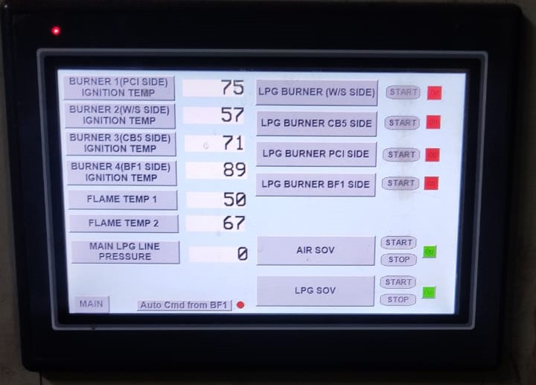

1. Start/Stop button available on PLC.
2. First four will Indicate Burner Temperatures, next two flame temperatures. On Main, BF1 or GEL flare stack can be selected
3. When "START" push button is pressed, ignition spark will go for 10sec and "IGNITION ON" LED will glow on panel for 10sec. For GEL F.S each burner is having 3 ignition electrodes. Ignition spark can be given through any of 3 ignition electrodes. Ignition electrodes can be selected with help of selector switch provide on control panel.
4. Burner inside temperature and flare stack top burnt out gas temperature is displayed on temperature indicators on control panel. To ensure proper flaring of exhaust gas burner temperature has to around 500-550°C.
5. LPG provision is also given in case flame temperature is not sustaining. In case GEL F.S not flaring, a command in auto comes from BF1 PLC to give LPG support to burner2 temperature. LPG support for Burner1 GEL F.S and BF1 F.S can be given by operating manual valve from F.S panel room.
6. To make sure with LPG automation works and flare stack flares, A pressure switch is provided at LPG line. In case LPG cylinder is empty alarm will come in BF1 control room.
7. GEL flare stack not flaring” will come only in case Flame does not sustain after 2 minutes of LPG introduction.
8. LPG cylinders to be connected to the manifold at any given time and only two no cylinders are allowed to kept as spare i.e. 100 kg.
9. 1st shift SS should check status of LPG cylinder at both flare stack and Control room engineer should update through mail to stores.

|  |  |  |
| --- | --- | --- |
| **Prepared By:**  Head – Production PID I | **Reviewed & Issued By:**  Management Representative | **Approved By:**  Head – Pig Iron Division |
| **Signature:** | **Signature:** | **Signature:** |
| **Date: 15.07.2022** | **Date: 15.07.2022** | **Date: 15.07.2022** |

|  |  |  |  |
| --- | --- | --- | --- |
| **Amendment Record** | | | |
| **Revision date** | **Manual Section ref. and para** | **Brief details of revision** | **New Revision No.** |
| 12.07.2021 | Procedure for GEL flare stack | Point no 1,2,3, 10 | 02 |
| 15.07.2022 | Procedure for GEL flare stack | Change in format | 03 |